|  |  |
| --- | --- |
|  |  |
| Plate Buckling Analysis | |
| User Manual | |
| April 25, 2018 | |



|  |  |  |  |  |  |
| --- | --- | --- | --- | --- | --- |
| Rev | Description | Date | Prep | Chk'd | Apprv'd |
| 01 | New Document | 25-April-2018 | VA |  |  |
|  |  |  |  |  |  |
|  |  |  |  |  |  |

Revision History

|  |  |  |  |
| --- | --- | --- | --- |
| Rev | Description | Section | Pages |
| 01 | New document | - | - |
|  |  |  |  |
|  |  |  |  |

CONTENTS

1 INTRODUCTION 3

2 THEORY 3

2.1 Introduction 3

2.2 DNV C201 3

2.2.1 Failure Modes. 3

2.2.2 Boundary and loading conditions. 4

2.2.3 Limits. 4

2.2.4 Plate Size limits: 4

2.2.5 Load Limits: 4

2.3 Serviceability limit states. 4

2.4 Validity. 5

Appendix A - Example Code 5

A.1 Input Function 5

A.2 Calculation 7

3 Buckling of plates. 14

3.1 In Edge Compression. 14

3.1.1 Tangent modulus factor. 18

3.2 Buckling of plates under shear. 19

3.3 Summary. 22

3.4 Buckling stress curves (Compression) 23

3.5 Factor of safety. 25

3.6 Effective width of plates in compression. 26

3.7 Buckling stress curves shear. 29

4 Introduction. 31

4.1 Types of instability. 32

4.1.1 Buckling strength Analysis. 32

4.1.2 Usage Factor. 33

4.1.3 Fabrication Tolerances. 33

4.2 Bar and Frames. 34

4.2.1 Characteristic buckling resistance. 35

4.2.2 Column Buckling. 39

4.2.3 Lateral Torsional of Buckling system. 44

4.2.4 Buckling of beam-columns. 45

4.2.5 Buckling of frames. 47

4.3 Unstiffened spherical shells. 53

4.3.1 Stresses. 53

4.3.2 Shell buckling, general. 54

4.3.3 Buckling of dished ends convex to pressure. 56

# INTRODUCTION

Dynacard data program evaluates the analytics application performs the following:

* The guidance for service delivery in section XX
* The user manual for developer in section XX

The document contains the following:

* Guidance notes for business users in Sub-section 2.1
* Guidance notes for service delivery in Sub-section 2.2
* Guidance notes for developer in Sub-section 2.3

# THEORY

## Introduction

Also, can we draw a picture of the plate and show the loading, stiffners, etc. We already have examples in SEWOL and codes. But how can we communicate this to a common user on internet?!?

## DNV C201

Buckling of flat plates may be experienced when the plate is excessively stressed in compression along opposite edges, or in shear uniformly distributed around all edges of the plate or a combination of both. This necessitates establishment of values for the critical buckling stress in compression (a) and in shear (G).

### Failure Modes.

This recommended practice addresses failure modes for unstiffened and stiffened plates, which are not covered by the cross sectional check of members. Such failure modes are:

* Yielding of plates in bending due to lateral load.
* Buckling of slender plates (high span to thickness ratio) due to in-plane compressive stresses or shear stresses.

Guidance for determining resistance is given both for individual plates (unstiffend plates), stiffened plates and for girders supporting stiffended plate panels. For stiffened panels the recommendations cover panel buckling, stiffener buckling as well as local buckling of stiffener and girder flanges, webs and brackets.

### Boundary and loading conditions.

The Serviceability and Ultimate are the loading conditions that will also change some factors and hence the results.

* Loading conditions
  + Serviceability.
  + Ultimate.

The simply supported and sides clamped are the boundary condition that will also change the results. We have to capture this as well by repeating the calculation.

* Boundary conditions.
  + Simply supported.
  + And sides clamped.

### Limits.

### Plate Size limits:

The plate size limits for a given load such as the plate length or breadth becomes longer, it will fail. So we can find the plate thickness, plate size limits for a given loading on a plate for any component. There are 3 variations and this will be 3-D surface plot if we try find the result.

### Load Limits:

The load limits for a given plate size are the loads (longitudinal, transverse, shear) that can be varied to find the limiting loads on a given plate. There are 3 variations and this will be 3-D surface.

CAN You DO THIS

## Serviceability limit states.

Check of serviceability limit states for slender plates relatedto out of plane deflection may normally be omitted if the smallest span of the plate is less than 120 times the plate

thickness.

CAN You DO THIS

## Validity.

This Recommended Practice is best suited to rectangularplates and stiffened panels with stiffener length being larger than the stiffener spacing ( l > s ). It may also be used for girders being orthogonal to the stiffeners and with the girder having significant larger cross-sectional dimensions than the stiffeners.

- Example Code

Input Function

The following shows how to determine the inputs for a plate buckling calculations and these inputs have been read through munch module.

* import munch
* plateGData1 = {'PlateLength': 2.69, 'PlateLength_unit' : 'm',
  + 'PlateBreadth' : 0.70, 'PlateBreadth_unit' : 'm',
  + 'PlateThickness' : 0.014, 'PlateThickness_unit' : 'm',
  + 'AverageWaterDepth' : 40, 'AverageWaterDepth_unit' : 'm',
  + 'YieldStrength' : 34 , 'YieldStrength_unit' : 'ksi',
  + 'PoissionsRatio' : 0.30,
  + 'YoungsModulus' : 30450, 'YoungsModulus_unit' : 'ksi'}
* plateGDataFT1 = {'PlateLength': 8.82, 'PlateLength_unit' : 'ft',
  + 'PlateBreadth' : 2.30, 'PlateBreadth_unit' : 'ft',
  + 'PlateThickness' : 0.046, 'PlateThickness_unit' : 'ft',
  + 'AverageWaterDepth' : 131.23, 'AverageWaterDepth_unit' : 'ft',
  + 'YieldStrength' : 34 , 'YieldStrength_unit' : 'ksi',
  + 'PoissionsRatio' : 0.30,
  + 'YoungsModulus' : 30450, 'YoungsModulus_unit' : 'ksi'}
* plateGLoading1 = {'LongtudinalStress' : 0.5, 'LongtudinalStress_unit' : 'ksi',
  + 'TransverseStress' : 0.5, 'TransverseStress_unit' : 'ksi',
  + 'ShearStress' : 0.7, 'ShearStress_unit' : 'ksi'}

# How to access objects from above dictionaries (also same for JSON format files)

* constantGvalue1 = {'BucklingFactor' : 0.26,

'BCedges_simplysupported_long': 4,

'BC_sideclamped_long' : 7.00,

'Resulting material factor': 1.15,

'H4' : 101325,

'H5' : 1025 ,

'H6' : 9.81,

'H7' : 0.000145038,

'H8' : 0.001,

'BR_transversedirection' : 1,

'Integralfactor' : 0,

'BA_sheardirection' : 1}

The script below shows how to read above inputs through munch module.

* constantGvalue = munch.munchify(constantGvalue1)
* plateGData = munch.munchify(plateGData1)
* plateGDataFT = munch.munchify(plateGDataFT1)
* plateGLoading = munch.munchify(plateGLoading1)
* l_G = plateGDataFT["PlateLength"]
* s_G = plateGDataFT["PlateBreadth"]
* t_G = plateGDataFT["PlateThickness"]
* d_G = plateGDataFT["AverageWaterDepth"]
* f_G = plateGDataFT["YieldStrength"]
* p_G = plateGDataFT["PoissionsRatio"]
* E_G = plateGDataFT["YoungsModulus"]
* L_G = plateGData["PlateLength"]
* S_G = plateGData["PlateBreadth"]
* T_G = plateGData["PlateThickness"]
* D_G = plateGData["AverageWaterDepth"]
* σG_xx = plateGLoading["LongtudinalStress"]
* σG_yy = plateGLoading["TransverseStress"]
* τ_G = plateGLoading["ShearStress"]
* k4_G = constantGvalue["BucklingFactor"]
* c_xx = constantGvalue["BCedges_simplysupported_long"]
* cxx = constantGvalue["BC_sideclamped_long"]
* ϒ_M = constantGvalue["Resulting material factor"]
* x7 = constantGvalue["H4"]
* x8 = constantGvalue["H5"]
* x9 = constantGvalue["H6"]
* x10 = constantGvalue["H7"]
* x11 = constantGvalue["H8"]
* C_τ = constantGvalue["BR_transversedirection"]
* ci_1 = constantGvalue["Integralfactor"]
* C_τe2 = constantGvalue["BA_sheardirection"]

Calculation

The following first line indicates how to take parametric inputs from the input line.

* from DataProvision.parameters_Col_All import *
* from math import sqrt

# How to access objects from above dictionaries (also same for JSON format files)

* σG_xx,σG_yy,τ_G
* x1=s_G/l_G
* x2=l_G/s_G
* c=(2-x1)
* x3=t_G/s_G
* x4=s_G/t_G
* x5=l_G/t_G

Buckling strength analyses shall be based on the characteristic buckling strength for the most unfavourable buckling mode. The characteristic buckling strength shall be based on the

lower 5th percentile of test results.

# FEA Analysis Stress (No Reduction Factor is used in Spreadsheet)

* σ_e1=sqrt(σG_xx**2+σG_yy**2-(σG_yy*σG_xx)+(3*τ_G**2)) # Vonmises Stress (σe)

# Characteristic Material Resistance, σk

* σ_kx=f_I
* σ_ky=f_I
* τ_k=f_I/sqrt(3)
* σ_e=f_I

# Edges Simply supported - Uniform Loading

* c_yy=(1+x1**2)**2
* c_τ=(5.34+4*x1**2)

# Elastic Buckling Resistance for each stress direction

* x6=3.14159**2*E_I/12/(1-p_I**2) # PI()^2*G38/12/(1-G37^2)
* σExx_Simp=x6*c_xx*x3**2
* σEyy_Simp=x6*c_yy*x3**2
* τE_simp=x6*c_τ*x3**2

# Reduced Slenders ratio # σG_xx,σG_yy,τ_G

* λx_simp=round(sqrt(σ_kx/σExx_Simp),2)
* λy_simp=sqrt(σ_ky/σEyy_Simp)
* λτ_simp=sqrt(τ_k/τE_simp)
* λe_simp=sqrt(f_I/σ_e1*((σG_xx/σExx_Simp)**c+(σG_yy/σEyy_Simp)**c+(τ_G/τE_simp)**c)**(1/c))

# Characteristic Buckling Resistance for serviceability

* σscrx_simp=σ_kx/sqrt(1+λx_simp**4)
* σscry_simp=σ_ky/sqrt(1+λy_simp**4)
* σscrz_simp=τ_k/sqrt(1+λτ_simp**4)
* σescr_simp=f_I/sqrt(1+λe_simp**4)

# Usage factor for serviceability check, Simply Supported.

* ηsx_simp=σG_xx/σscrx_simp
* FALSE=σG_yy/σscry_simp
* ηsz_simp=τ_G/σscrz_simp
* ηse_simp=σ_e1/σescr_simp

# Characteristic Buckling Resistance for Ultimate check.

* σucrx_simp1=(σ_kx/(sqrt(1+λx_simp**4)))
* σucrx_simp2=σ_kx/sqrt(2)/λx_simp
* if(λx_simp<1):
* print("The value of σucrx_simp1 is ",σucrx_simp1)
* else:
* print("The value of σucrx_simp2 is",σucrx_simp2)
* σucry_simp1=(σ_ky/(sqrt(1+λy_simp**4)))
* σucry_simp2=σ_ky/sqrt(2)/λy_simp
* if(λy_simp<1):
* print("The value of σucry_simp1 is ",σucry_simp1)
* else:
* print("The value of σucry_simp2 is",σucry_simp2)
* σucrz_simp1=(τ_k/(sqrt(1+λτ_simp**4)))
* σucrz_simp2=τ_k/sqrt(2)/λτ_simp
* if(λτ_simp<1):
* print("The value of σucrz_simp1 is ",σucrz_simp1)
* else:
* print("The value of σucrz_simp2 is",σucrz_simp2)
* σeucr_simp1=(σ_e/(sqrt(1+λe_simp**4)))
* σeucr_simp2=σ_e/sqrt(2)/λe_simp
* if(λe_simp<1):
* print("The value of σeucr_simp1 is ",σeucr_simp1)
* else:
* print("The value of σeucr_simp2 is",σeucr_simp2)

# Usage factor for ultimate check, , Simply Supported.

* ηux_simp=σG_xx/σucrx_simp1
* ηuy_simp=σG_yy/σucry_simp2
* ηuz_simp=τ_G/σucrz_simp1
* ηue_simp=σ_e1/σeucr_simp2

# Sides clamped - Uniform Loading

* cyy=(1+2.5*x1**2+5*x1**4)
* cτ=(9+5.6*x1**2)

# Elastic Buckling Resistance for each stress direction.

* σExx_Simp=x6*cxx*x3**2
* σEyy_Simp=x6*cyy*x3**2
* τE_Simp=x6*cτ*x3**2

# Reduced Slenders ratio.

* λx_side=sqrt(σ_kx/σExx_Simp)
* λy_side=sqrt(σ_ky/σEyy_Simp)
* λτ_side=sqrt(τ_k/τE_Simp)
* λe_side=sqrt(f_I/σ_e1*((σG_xx/σExx_Simp)**c+(σG_yy/σEyy_Simp)**c+(τ_G/τE_Simp)**c)**(1/c))

# Characteristic Buckling Resistance for serviceability.

* σscrx_side=σ_kx/sqrt(1+λx_side**4)
* σscry_side=σ_ky/sqrt(1+λy_side**4)
* σscrz_side=τ_k/sqrt(1+λτ_side**4)
* σescr_side=f_I/sqrt(1+λe_side**4)

# Usage factor for serviceability check, Sides Clamped.

* ηsx_side=σG_xx/σscrx_side
* ηsy_side=σG_yy/σscry_side
* ηsz_side=τ_G/σscrz_side
* ηse_side=σ_e1/σescr_side

# Characteristic Buckling Resistance for Ultimate Check.

* σucrx_side1=σ_kx/(sqrt(1+λx_side**4))
* σucrx_side2=σ_kx/sqrt(2)/λx_side
* if(λx_side<1):
* print("The value of σucrx_side1 is ",σucrx_side1)
* else:
* print("The value of σucrx_side2 is",σucrx_side2)
* σucry_side1=σ_ky/(sqrt(1+λy_side**4))
* σucry_side2=σ_ky/sqrt(2)/λy_side
* if(λy_side<1):
* print("The value of σucry_side1 is ",σucry_side1)
* else:
* print("The value of σucry_side2 is",σucry_side2)
* σucrz_side1=τ_k/(sqrt(1+λτ_side**4))
* σucrz_side2=τ_k/sqrt(2)/λτ_side
* if(λτ_side<1):
* print("The value of σucrz_side1 is ",σucrz_side1)
* else:
* print("The value of σucrz_side2 is",σucrz_side2)
* σeucr_side1=σ_e/(sqrt(1+λe_side**4))
* σeucr_side2=σ_e/sqrt(2)/λe_side
* if(λe_side<1):
* print("The value of σeucr_side1 is",σeucr_side1)
* else:
* print("The value of σeucr_side2 is",σeucr_side2)

# Usage factor for ultimate check, Sides Clamped.

* ηux_side=σG_xx/σucrx_side1
* ηuy_side=σG_yy/σucry_side2
* ηuz_side=τ_G/σucrz_side1
* ηue_side=σ_e1/σeucr_side2

# Buckling resistance stress in longitudinal direction.

Buckling checks of unstiffened plates in compression shall be made according to the effective width method. The reduction in plate resistance for in-plane compressive forces is expressed by a reduced (effective) width of the plate which is multiplied by the design yield strength to obtain the design resistance.

The design buckling resistance of an unstiffened plate under longitudinal compression force may be calculated as.

* λ_p=0.525*x4*sqrt(f_I/E_I)
* Cx=(λ_p-0.22)/λ_p**2
* if(λ_p>0.673):
* print("The value for slendrness grater than equal to (0.673)",Cx)
* else:
* print("The value is",1)
* σxrd=Cx*f_I/ϒ_M

# Buckling resistance stress in Transverse direction.

In case of linear varying transverse stress the capacity check can be done by use of the design stress value at a distance l1 from the most stressed end of the plate, but not less than 0.75

of maximum σy,Sd.

The design buckling resistance of a plate under transverse compression force may be found from:

* λ_c=1.1*x4*sqrt(f_I/E_I)
* µ=0.21*(λ_c-0.2)
* k1=1 # if(l_c<=0.2): print("the value of k",k)
* k2=1/(2*λ_c**2)*((1+µ+λ_c**2)-sqrt((1+µ+λ_c**2)**2-4*λ_c**2))
* k3=1/(2*λ_c**2)+0.07
* p_Sd_pa=101325+1025*D_G*x9
* p_Sd_ksi=p_Sd_pa*x10*x11
* x12= 2*(x3**2)*f_I #x7=2*(t_G/s_G)^2*f_y
* #IF(0.05*G43-0.75<0,0,0.05*G43-0.75)
* h_α1=0.05*x4-0.75
* h_α2=0.05*x4-0.75
* if(h_α1<0):
* print(" The value of h_α1 is",0)
* else:
* print(" The value of h_α is",h_α2)
* Kp1=1
* Kp2=1-h_α2*((p_Sd_ksi/f_I)-2*x3**2)
* if(p_Sd_ksi<=p_Sd_pa):
* print(" The value of Kp is",Kp1)
* else:
* print(" The value of Kp is",Kp2)
* σy_R=(1.3*t_G/l_G*sqrt(E_I/f_I)+k4_G*(1-1.3*t_G/l_G*sqrt(E_I/f_I)))*f_I*Kp1
* σy_rd=σy_R/ϒ_M

# Buckling resistance stress in Shear direction.

* kl_1=5.34+4*(x1)**2
* kl_2=5.34*x1**2+4
* if(x1<1):
* print("The value of kl_1 is",kl_1)
* else:
* print("The value of kl_2 is",kl_2)
* λ_w=0.795*x4*sqrt(f_I/(E_I*kl_1))
* if(λ_w>1.2):
* print(0.9/λ_w)
* if(λ_w>0.8):
* print(1-0.625*(λ_w-0.8))
* else:
* print("The value of C_τ is",C_τ)
* τ_rd=C_τ/ϒ_M*f_I/sqrt(3)

# Buckling resistance stress in Bi-axial with Shear direction.

A plate subjected to biaxially loading with shear should fulfil the following requirement where if both σx,Sd and σy,Sd is compression (positive) then ci_2=(1-s_G/(120*t_G)) for s/t <= 120

And ci_2=0 for s/t > 120.

If either of σx,Sd and σy,Sd or both is in tension (negative), then ci = 1.0.

In order to perform cross sectional checks for members subjected to plate buckling the local buckling effects can be accounted for by checking the resistance by using the effective width.

* ci_2=(1-s_G/(120*t_G))
* if(x4>120):
* print("The value of ci_1",ci_1)
* else:
* print("The value of ci_2",ci_2)
* k_l=kl_1
* λ_w=λ_w
* C_τe1=(1-0.8*(λ_w-0.8))
* if(λ_w>1.25):
* print(1/λ_w**2)
* if(λ_w>0.8):
* print("The value of C_τe1 is",C_τe1)
* else:
* print("The value of C_τe2 is",C_τe2)
* τrd=C_τe2/ϒ_M*f_I/sqrt(3)
* σ_xrd=σxrd
* σ_yrd=σy_rd
* τ_rd=τrd
* x15=(σG_xx/σ_xrd)**2+(σG_yy/σ_yrd)**2-ci_2*(σG_yy/σ_xrd)*(σG_yy/σ_yrd)+(τ_G/τ_rd)**2

# DNV-RP-C201 Usage factor

* Longitudinal=σG_xx/σxrd
* Transverse=σG_yy/σy_rd
* Shear=τ_G/τ_rd
* Biaxial=sqrt(x15)

# Buckling of plates.

Buckling of flat plates may be experienced when the plate is excessively stressed in compression along opposite edges, or in shear uniformly distributed around all edges of the plate or a combination of both. This necessitates establishment of values for the critical buckling stress in compression (σcr) and in shear ($τcr$).

## In Edge Compression.

This critical compressive stress of a plate when subject to compression (σcr) can be found from the following.

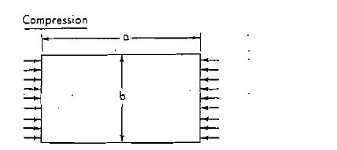

$$σcr=\frac{kπ^{2}E}{12\left(1-μ^{2}\right)} {\left(\frac{l}{b}\right)}^{2}$$

Where:

E = modulus of elasticity in compression (Steel = 30,000,000 psi)

t = thickness of plate, inches

b = width of plate, inches

a = length of plate, inches

v = Poisson's ratio (for steel, usually = 0.3)

k = constant (depends upon plate shape (b/a) and support of sides).

If the resulting critical stress (σcr) from this formula is below the proportional limit (σy), buckling is said to be elastic and is confined to a portion of the plate away from the supported side thus does not mean complete collapse of the plate at this stress. This is

Represented by the portion of the C to. D .If the resulting value (σcr) is the Proportional limit. (σp), indicated by the portion of the curve A to C, buckling is said to be inelastic. Here, the tangent modulus (Et) must be used in some form to replace Young's or secant modulus (E) in the formula for determining (σcr).

This problem can be simplified by limiting the maximum value of the critical buckling stress (σcr) to the yield strength (σε) However, the value of the critical buckling stress (σcr) may be calculated if required.

Above the proportional limit (σp), the ratio $E=\frac{σ}{ϵ}$ no longer constant, but varies, depending upon the type of steel (represented by its stress-strain diagram) and the actual stress under consideration (position on the stress-strain diagram).

|  |  |
| --- | --- |
| **Values for plate factor (k) to be used in formula** | **Critical stress on plate to cause Buckling** |
| K=0.425 | $${σ'}_{cr}=σ_{cr}$$ |
| K=1.277 | $${σ'}_{cr}=σ_{cr}$$ |
| K=4.00 | $${σ'}_{cr}=σ_{cr}$$ |
| K=5.42 | $${σ'}_{cr}=σ_{cr}$$ |
| K= 6.97 | $${σ'}_{cr}=σ_{cr}$$ |

Table 3‑1 Compression on load plate.

Above the proportional limit (σP) the modulus of elasticity (E) must be multiplied by a factor (A) to give the tangent modulus (Et). The tangent modulus (Et) is still the slope of the stress-strain diagram and $Et=\frac{σ}{ε_{t}}$ but it varies.

If it is assumed that the plate is isotropic" (i.e., having the same properties in both directions x and y), the critical buckling formulas becomes. Where

$$λ=\frac{Et}{E}$$

$$σcr=\frac{π^{2} E λ}{12(1-μ^{2)}} {\left(\frac{t}{b}\right)}^{3}k$$

If it is assumed that the plate has "anisotropic" behaviour (i.e. not having the same properties in both directions x and y), the tangent modulus (Et) would be used for stress in the x direction when the critical stress (σcr) is above the proportional limit (σp) .However, the modulus of elasticity (E) would be used in the y direction because any stress in this direction would be below the proportional limit (σp). In this case, the above formula would be conservative and the following would give better results.

$$σcr=\frac{σy {\left(\frac{σcr }{\sqrt{λ}} \right)}^{2}}{.1836 {σy}^{2} + {\left(\frac{σcr}{√λ}\right)}^{2}}$$

$$σcr=\frac{π^{2} E \sqrt{λ}}{12(1-μ^{2)}} {\left(\frac{t}{b}\right)}^{2}k$$

For the steel becomes

$$σcr=2.710*{10}^{τ}*\sqrt{λ} {\left(\frac{t}{b}\right)}^{2}k$$

If the critical buckling stress (σcr) is less than the Proportional limit (σcr) then $λ=\frac{Et}{E}=1$ and

formula #4 could be used directly in solving for critical stress (σcr).

However, if the critical buckling stress (σcr) is Greater than the proportional limit (σp), then $λ<1$ and formula #4 cannot be used directly. It would be better to divide through by $\sqrt{λ}$ and express the formula as

$$\frac{σcr}{√λ}=2.710*{10}^{τ}* {\left(\frac{t}{b}\right)}^{2}k$$

From the value of $\frac{σcr}{\sqrt{λ}}$ will give the value of (σcr) .Obtain proper value for the plate

factor (k) from Table 1 or 3.

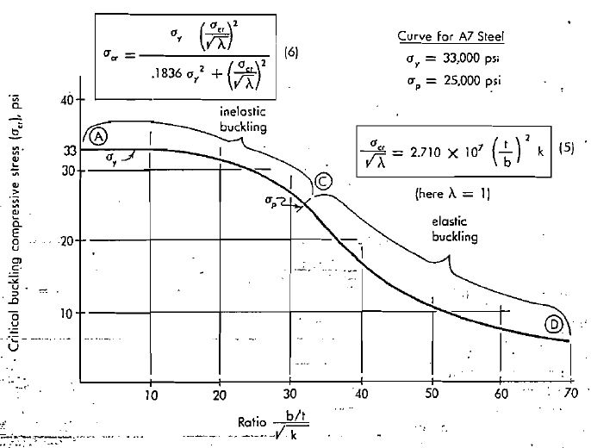

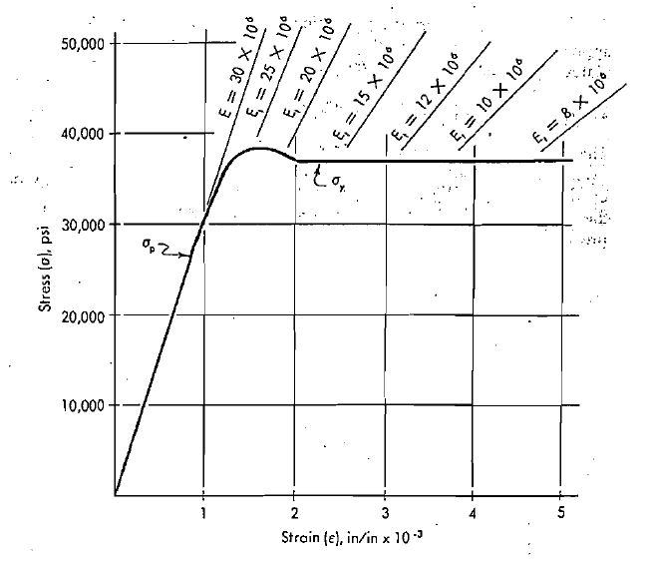

### Tangent modulus factor.

Blecich in "Buckling Strength” of Metal Structures" gives the following expression for this factor $λ=\frac{Et}{E}$.

$$λ=\frac{\left(σy-σcr\right) σcr}{\left(σy-σp\right) σp}$$

Where:

(σy) = Yield Point

(σp) = Proportional Limit

(σcr) = Critical Buckling stress.

If we use a ratio of $\frac{σy}{σp}=1.32$ the expression becomes.

$$λ=\frac{\left(σy-σcr\right) σcr}{\left(σy-\frac{σ}{1.32}\right) \frac{σ}{1.32}}$$

$$=\frac{ σcr σy-{σcr}^{2}}{.1836 {σy}^{2}}$$

Then, multiply through by $\frac{σcr}{λ}$

$$σcr=\frac{ σy {\left(\frac{σcr}{\sqrt{λ}}\right)}^{2}}{.1836 {σy}^{2}+{\left(\frac{σcr}{√λ}\right)}^{2} }$$

|  |  |
| --- | --- |
| Values for plate factor (k) to be used in formula | Critical stress on plate to cause Buckling(τ’cr) |
| $$k=5.34+\frac{4}{a^{2}}$$ | $$τ'cr=\frac{σcr}{\sqrt{3}}$$ |
| $$k=8.98+\frac{5.6}{a^{2}}$$ | $$τ'cr=\frac{σcr}{\sqrt{3}}$$ |

Table 3‑2 Shear on load plate.

## Buckling of plates under shear.

The critical buckling shearing stress (τcr) of a plate when subject to shear forces (τ t) may be expressed by the formula. (Similar to that used for the critical buckling stress for plates in edge compression).

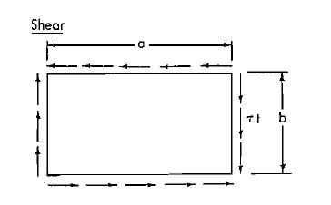

$$τcr= \frac{kπ^{2}E}{12\left(1-μ^{2}\right)} {\left(\frac{t}{b}\right)}^{2}$$

Where:

E = modulus of elasticity in compression (Steel = 30,000,000 psi)

t = thickness of plate, inches

b = width of plate, inches

a = length of plate, inches(a is always the larger of the plate dimensions)

v = Poisson's ratio (for steel, usually = 0.3)

k = constant (depends upon plate shape (b/a) and edge restraint and also accounts for the modulus of elasticity in shear Ea).

It is usual practice to assume the edges simply supported .Shear yield strength (τ) is usually considered as $\frac{1}{\sqrt{3}}$ of the yield strength $σy$ or .58 $σy$

Since the plate constant (k) can be adjusted to contain the 3 factor this becomes.

Since $$τcr=\frac{σcr}{\sqrt{3}}$$

$$σcr= \frac{\sqrt{3}kπ^{2}E}{12\left(1-μ^{2}\right)} {\left(\frac{t}{b}\right)}^{2}$$

|  |  |
| --- | --- |
| Values for plate factor(k) to be used in formulas | Critical stress (τ’cr) and (σ’cr) |
| When $a≥1$ $k=4$ When $a≤1$ $k={\left(a+\frac{1}{a}\right)}^{2}$ | $${σ'}_{cr}=σ_{cr}$$ |
| When $a≥1$ $k=7.7$ When $a≤1$ $k=7.7+33 {\left(1-a\right)}^{2}$ | $${σ'}_{cr}=σ_{cr}$$ |
| When $a≥\frac{2}{3}$ $k=24$ When $a≤\frac{2}{3}$ $k=24+73 {\left(\frac{2}{3}-a\right)}^{2}$ | $${σ'}_{cr}=σ_{cr}$$ |
| When $a≥1$ $k=\sqrt{3}\left(5.34+ \frac{4}{a^{2}}\right)$ When $a≤1$ $k=\sqrt{3}\left(4+ \frac{5.34}{a^{2}}\right)$ | $${σ'}_{cr}=σ_{cr}$$ |

Table 3‑3 Critical stress for rectangular plates on 4 sides

As before in the buckling of plates by compression, in the inelastic range the critical stress (σcr)

exceeds the proportional limit (σp) and the tangent modulus (Et) is introduced by the factor $\left(λ=\frac{Et}{E}\right)$.Therefore, formulas #5 and #6 would be used also in the buckling of plates by shear.

Proper values for the plate factor (k) are obtained from Table 2 for pure shear load, and Table 3, for shear load, combined with compression.

|  |  |
| --- | --- |
| **Values for plate factor (k) to be used in formulas** | **Critical stress (τ’cr) and (σ’cr)** |
| When $a≥1$ $k=2η^{2}β \sqrt{β^{2}+3} \left[-1+ \frac{4}{β^{2}π^{2}}\right]$  Where $n=\frac{4}{3}+ \frac{1}{a^{2}}$ $$when \frac{1}{2}≤a≤1$$ $$k=\frac{η^{2}}{2} {\left(a+\frac{1}{a^{2}}\right)}^{2}β \sqrt{β^{2}+3 }\left[-1+\sqrt{1+\frac{4}{β^{2}η^{2}}}\right]$$ $Where η=\frac{4 a^{2}+5.34}{{\left(a^{2}+1\right)}^{2}}$ | $$τ^{'}cr=\frac{σcr}{\sqrt{β^{2}+3}}$$ $$σ^{'}cr=\frac{β σcr}{\sqrt{β^{2}+3}}$$ |
| When $a≥1$ $k=3.85 η^{2}β \sqrt{β^{2}+3} \left[-1+\sqrt{1+ \frac{4}{β^{2}η^{2}}}\right]$  Where $n=\frac{5.34+\frac{4}{a^{2}}}{7.7}$ $$when \frac{1}{2}≤a≤1$$ $k=3.85 η^{2}β \sqrt{β^{2}+3} \left[-1+\sqrt{1+ \frac{4}{β^{2}η^{2}}}\right]$ $Where η=\frac{4 +\frac{5.34}{a^{2}}}{7.7+33 {\left(1-a\right)}^{2}}$ | $$τ^{'}cr=\frac{σcr}{\sqrt{β^{2}+3}}$$ $$σ^{'}cr=\frac{β σcr}{\sqrt{β^{2}+3}}$$ |
| When $a≥1$ $k=24 η\sqrt{β^{2}+3} \left[\sqrt{\frac{1}{1+ β^{2}{η }^{2})}}\right]$  Where $n=\frac{2}{9}+ \frac{1}{{6a}^{3}}$ $$when \frac{1}{2}≤a≤1$$ $k=24 η\sqrt{β^{2}+3} \left[\sqrt{\frac{1}{1+ β^{2}{η }^{2})}}\right]$ Where $n=\frac{1}{6}+ \frac{2}{{9a}^{2}}$ | $$τ^{'}cr=\frac{σcr}{\sqrt{β^{2}+3}}$$ $$σ^{'}cr=\frac{β σcr}{\sqrt{β^{2}+3}}$$ |

3‑1 Critical stress for rectangular plates on 4 sides

## Summary.

1. The value of the plate factor (k) to be used in formula #5 comes from Tables 1, 3 or 3, adapted from "Buckling Strength of metal Structures", Bleich, pp 330, 395, 410.
2. Solve for $\frac{σcr}{\sqrt{λ}}$ from formula #5.

a. If $\frac{σcr}{\sqrt{λ}}=σp$ this is the value of σcr, so go to step 4.

b. If $\frac{σcr}{\sqrt{λ}}>σp$ go to step 3.

1. Insert this value $\frac{σcr}{\sqrt{λ}}$ in to the formula 6, and solve for the critical buckling stress (σcr).

4. After the critical stress (σcr) has been determined, the critical buckling stress of the given plate

Is (σcr or τcr) determined from the relationship shown in the right-hand column of Tables 1, 3, or 3.

## Buckling stress curves (Compression)

In regard to plates subjected only to compression or only to shear, H , M. Priest and J. Gilligan in their "Design Manual for High Strength Steels" show the curve patterns, Figure 5 (compression) and Figure 10 (shear). They have divided the buckling curve into three distinct portions (A-B, B-C, and C-D), and have lowered the critical stress values in the elastic buckling

region by 25% to more nearly conform to actual test results.

Values indicated on this typical curve are for ASTM A-7 (mild) steel, having a yield strength of

33,000 psi. The buckling curve (dashed line) of Figure2 has been superimposed on the Priest-Gillizan curve for comparison.

The horizontal line (A to B) is the limit of the yield strength (σcr) .Here (σcr) is assumed equal to (σy). The curve from C to D is expressed by.

|  |  |
| --- | --- |
| **Factor $\frac{\left(\frac{b}{t}\right)}{\sqrt{k}}$** | **Critical buckling compressive stress(σcr) determined by** |
| $$0 to \frac{3820}{\sqrt{σy}}$$ | $$σcr=σy$$ |
| $$\frac{3820}{\sqrt{σy}} to \frac{5720}{\sqrt{σy}}$$ | $$σcr=1.8 σr-n \frac{\frac{b}{t}}{\sqrt{k}}$$ Where $n=\frac{\sqrt{{σ^{2}}_{y}}}{4770}$ |
| $$\frac{5720}{\sqrt{σy}} and over$$ | $$σcr={\left[\frac{4434}{\frac{\frac{b}{t}}{\sqrt{k}}}\right]}^{2}$$ |

Table 3‑4 Buckling stress formulas.

$$σcr=1.8 σy-n \frac{\left(\frac{b}{t}\right)}{\sqrt{k}}$$

Where $n=\frac{\sqrt{{σy}^{3}}}{4770}$

The curve from C to D is 75% of the critical buckling stress formula. Figure 1 or:

$$σcr= .75\frac{kπ^{2}E}{12\left(1-μ^{2}\right)} {\left(\frac{t}{b}\right)}^{2}$$

$$={\left[\frac{4434}{\frac{\frac{b}{t}}{\sqrt{k}}}\right]}^{2}$$

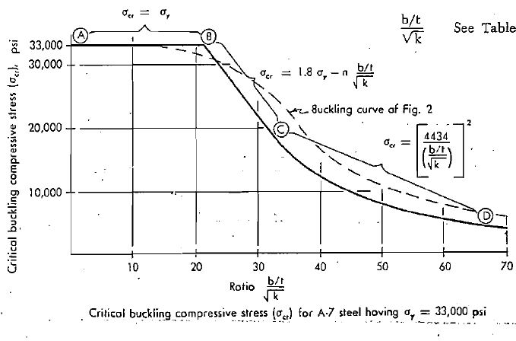

All of this is expressed in terms of the factor $\frac{\frac{b}{t}}{\sqrt{k}}$

Factors needed for the formula^ of curves in Figure 5, for steels of various yield strengths, are given in Table 5.

Figure 6 is just an enlargement of Figure 5, with additional steels having yield strengths from 33,000 psi to 100,000 psi.

For any given ratio of plate width to thickness (b/t), the critical buckling stress (σcr) can be read directly from this figure.

## Factor of safety.

A suitable factor of safety must be used with these values of b/t since they represent ultimate stress values for buckling. Some structural specifications limit the ratio (b/t) to a maximum value (point B) at which the critical buckling stress (σcr) equal to the yield strength (σy) . By so doing, it is not necessary to calculate the buckling stress. These limiting values of b/t, as specified

by several codes, are given in Table 6.

In general practice, somewhat more .liberal values of b/t are recognized. Table 7, extended to higher yield strengths, lists these limiting values of b/t.

## Effective width of plates in compression.

The 20" X 1/4" plate shown in Figure 7, simply supported along both sides, is subjected to n compressive load.

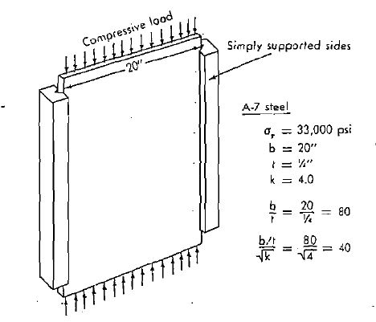

Under 'these conditions, the critical buckling compressive stress (σcr) as found from the curve (σy=33,000 psi) in Figure 6 is $σcr=12,280 psi$

Since the ratio $\frac{\frac{b}{t}}{\sqrt{k}}$ is 40.0 and thus exceeds the value of 31.5 for point C, the following formula

must be used.

$$σcr={\left[\frac{4434}{\frac{\frac{b}{t}}{\sqrt{k}}}\right]}^{2}={\left[\frac{4434}{40}\right]}^{2}=12,280 psi$$

At this stress, the middle portion of the plate would be expected to buckle, Figure 8. The compressive load at this stage of loading would be

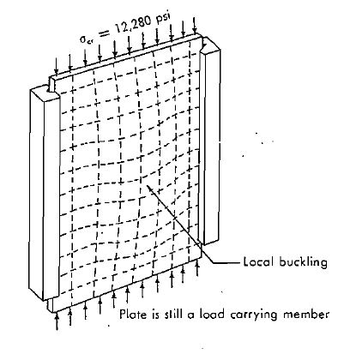

$$p=A σ=\left(20"*\left(\frac{1}{4}\right)\right) 12.280=61,400 lbs$$

The over-all plate should not collapse since the portion of the plate along the supported sides could still be loaded up to the yield point (σy) before ultimate collapse. This portion of the plate, called the "effective width" can be determined by finding the ratio b/t when (σcr) is set equal to yield strength (σy) or point B.

$$\frac{b}{t}=42.0$$

$$\frac{\frac{b}{t}}{\sqrt{k}}=21.0$$

Since $k=4.0$ (Both sides simply supported),the ratio

$$\frac{b}{t}=21.0\sqrt{k}=42.0$$

Since the plate thickness $t=\frac{1}{4} "width$ $b=42.0 t or b=10.5"$

This is the effective width of the plate which may be stressed to the yield point (σy) before ultimate collapse of the entire plate.

The total compressive load at this state of loading would be as shown in Figure 9.

The total compressive load here would be.

$$p=A1 σ1+A2 σ2$$

$$=\left( {10}^{\frac{1}{2}}*\frac{1}{4}\right) \left(33,000\right)+\left( 9^{\frac{1}{2 }}* \frac{1}{4}\right) \left(12,280\right)$$

$$=115,800 lbs$$

Another method makes no allowance for the central buckled portion as a load carrying member, it being assumed that the load is carried only by the supported portion of the plate. Hence the total compression load would be.

$$p=A1 σ1$$

$$=\left( {10}^{\frac{1}{2}}*\frac{1}{4}\right) \left(33,000\right)$$

$$=86,600 lbs$$

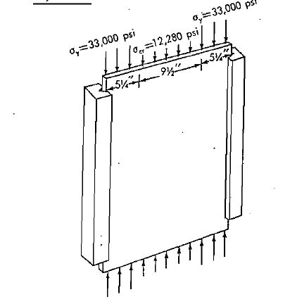

## Buckling stress curves shear.

The Priest & Cilligan curve, corresponding to Figure 5, when applied to the buckling of plates in shear is shown in Figure 10.

The curve is expressed in terms of $\frac{\frac{b}{t}}{\sqrt{k}}$ see Table 8. Comparison of Figure 10 and Table 8 with Figure 5 end Table 4 reveals the parallelism of critical buckling stress for compression (σcr) and for shear (τcr).

Figure is just an enlargement of Figure, with additional steels having yield strength from 33,000 psi to 100,000 psi. Factors needed for the formulas of curves in figure are given in Table 9.

For any value of the critical buckling shear stress (τcr) can be read directly from the curves of

this figure.

A suitable factor of safety must be used with these values since they represent ultimate stress values for buckling.

By holding the ratio of to the value at point B (τcr=τy) and it will not be necessary to compute the critical shear stress (τcr) assuming the edges are simply supported the value of $k=5.34+4{\left(\frac{b}{a}\right)}^{2}$ Then using just the three values of b/a as 1 (a square panel),1/2 (the length twice the width of panel) and zero (or infinite length), the required b/t value is obtained from Table 10 for steels of various yield strengths. The plate thickness is then adjusted as necessary to meet the requirement.

Notice in Figure 10 and Table 8 that the critical buckling stress in shear is given directly as.In Tables 2 and 3 it is given first as (σcr) and then changed to (τcr).

# Introduction.

In the rules for classification of ships (henceforth referred to as the rules), it is required that structural stability shall be provided for the structure as a whole and for each structural member.

There are basically two ways in which a structure may lose its stability. The type of instability shown in Fig.1.l a is known as snap-through buckling and is characterized by a load-deflection curve as indicated. The structure collapses when the load is increased beyond the limit point.

The other type of instability shown in Fig. l.l b is known as classical or bifurcation buckling. For relatively small loads, the equilibrium state of the structure is called the pre buckling state or the fundamental state. When the load is increased a bifurcation point is reached, at which another solution to the equilibrium equations exists. Beyond the bifurcation point the pre buckling path is unstable. The post buckling behaviour then depends on the characteristics of the secondary path.

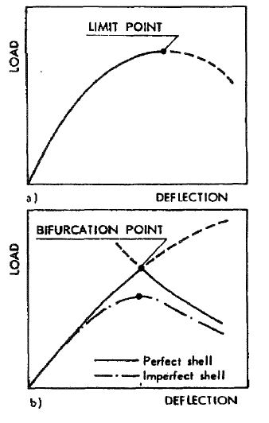

## Types of instability.

However, if the structure contains an initial geometric imperfection in the shape of the buckling mode, the load-displacement curve may be as indicated in Fig. 1.1b. It is seen that an imperfect structure may lose its stability at a limit point that corresponds to a lower load than the bifurcation point of the perfect structure. Whether the bifurcation-point load of the perfect structure is close to the limit-point load of the imperfect structure depends on the shape of the secondary path of the perfect structure.

Because geometric imperfections of various shapes are inevitable in fabricated structures, actual instabilities may be expected to occur at limit points rather than at bifurcation points.

### Buckling strength Analysis.

Buckling strength analyses are to be based on the characteristic buckling strength for the most unfavourable buckling mode. The characteristic buckling strength is to be based on the lower 5th percentile of test results. In lieu of more relevant information or more refined analysis, characteristic buckling strength values may be obtained from this Note.

* The general procedure for buckling strength analysis according to this Note may be described as follows:
* The state of stress in the structure under consideration is characterized by a reference stress, σ. This may be one single stress component, or a defined “equivalent” stress.

* The buckling strength of the structure is defined as the critical value of the reference stress, σcr.
* The critical stress may be defined relative to the yield stress, σF, in such a way that the ratio σcr/σF is determined as a function of the reduced slenderness parameter, λ. A typical buckling strength curve is shown in Fig. 1.2.
* The most general definition of structural slenderness is the reduced slenderness:

$$λ=\frac{σf}{σE}$$

where σE is the elastic buckling stress. In general σE may be determined from classical buckling theory, but for structures which are sensitive to imperfections in the elastic range, σE should be modified in such a way that imperfections within specified tolerances are accounted for.

* Typical buckling strength curves are characterized by a plateau, $\frac{σcr}{σF}=1.0$ for values of λ less than λo, see Fig.1.2. In such cases it may be concluded that buckling is not relevant when λ < λo. For a number of cases it has been found convenient to derive explicit slenderness limitations based on this criterion.

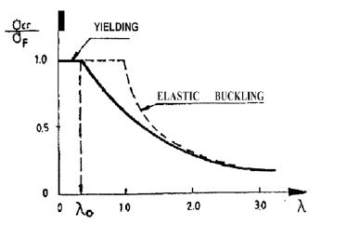

### Usage Factor.

The buckling stress analysis given in this Note is based on the allowable usage factor method.

The usage factor, η is defined as the ratio between the actual value of the reference stress due to design loading and the critical value of the reference stress, i.e.

$$η=\frac{σ}{σcr}$$

The maximum allowable value of the usage factor, ηp is defined in the rules. In general ηp depends on:

* Loading condition.
* Type of structure.
* Slenderness of structure.

### Fabrication Tolerances.

The buckling strength of most structures depends on size and shape of geometric imperfections. In general the effect of imperfections is only implicitly incorporated in the formulae for characteristic strength. This means that it has been assumed that the imperfections do not exceed certain limits. These limits are specified in Sec.5 of this Note.

A fabricated structure with imperfections exceeding the limits given in Chapter 7 of this Note should only be accepted if the actual usage factor with respect to buckling is found to be small compared to the allowable usage factor, or if it can be proved by adequate methods that the buckling strength of the imperfect structure is sufficient.

## Bar and Frames.

This chapter treats the buckling of bars and frames. Depending on the loading condition, a bar may be referred to as follows:

* Column bar subject to pure compression
* Beam bar subject to pure bending
* Beam-column bar subject to simultaneous bending and compression.

Buckling modes for bars are categorized as follows (see Fig. 2.1):

Flexural buckling of columns: bending about the axis of least resistance.

Torsional buckling of columns: twisting without bending. Flexural-torsional buckling of columns: simultaneous twisting and bending.

Lateral-torsional buckling of beams: simultaneous twisting and bending.

Local buckling: buckling of a thin-walled part of the cross-section (plate-buckling, shell-buckling).

The buckling mode which corresponds to the lowest buckling load is referred to as the critical buckling mode.

Flexural buckling may be the critical mode of a slender column of doubly symmetrical cross-section or one which is not susceptible to, or is braced against twisting.

Torsional buckling may be the critical mode of certain open, thin-walled short columns in which shear centre and centroid coincide (doubly-symmetrical I-shapes, anti-symmetrical Z-shapes, cruciforms etc.).

Flexural-torsional buckling may be the critical mode of columns whose shear centre and centroid do not coincide and which are torsional weak (thin-walled open sections in contrast to closed thick-walled or solid shapes). It should be emphasized that flexural-torsional buckling analysis is only needed when it is physically possible for such buckling to occur.

Lateral-torsional buckling may be the critical mode when a beam is subjected to bending about its strong axis and not braced against bending about the weak axis.

In this Note it is assumed that the cross-section of the member under consideration has at least one axis of symmetry (Z axis). Members with arbitrary cross-sections are subject to special considerations.

The following symbols are used without a specific definition in the text where they appear:

A = cross-sectional area.

E = Young's modulus.

G = shear modulus $\left(G=\frac{E}{2\left(1+μ\right)}\right)$

I = moment of inertia.

σF = yield stress of the material as defined in the rules.

ν = Poisson's ratio.

### Characteristic buckling resistance.

The characteristic buckling resistance of a compression member, σcr, is determined by use of the reduced slenderness,λ.

The reduced slenderness, λ, is defined by

$$λ=\frac{σf}{σE}$$

where σE is the elastic buckling stress for the buckling mode under consideration.

A compression member is defined as “stocky” if the reduced slenderness with respect to the critical column buckling mode is less than 0,2.

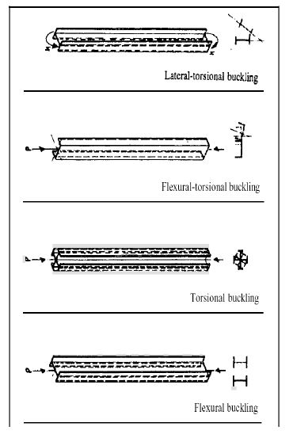

Non-dimensional buckling curves are given in Fig.2.2.For computations $\frac{σcr}{σf}$ may be obtained from:

|  |  |
| --- | --- |
| $$If λ≤λo$$ | $$\frac{σcr}{σF}=1.0$$ |
| $$If λ>λo$$ $$Where μ=α(λ-λo)$$ | $$\frac{σcr}{σF}=\frac{1+μ+ λ^{2}-\sqrt{(1+μ+ λ^{2})-4 λ}}{2λ^{2}}$$ |

The coefficients α and λo are given in Table

|  |  |  |
| --- | --- | --- |
| **Numerical values of λo and α** | | |
| Curve | λo | α |
| a | 0.2 | 0.20 |
| b | 0.2 | 0.35 |
| c | 0.2 | 0.5 |
| d | 0.2 | 0.65 |
| e | 0.6 | 0.35 |

.

The assignment of commonly used structural sections to column curves “a”, “b” or “c”. Curve “d” is a non-dimensional buckling curve for sniped plate stiffeners which is referred to in 3.4.5. Curve “e” applies to lateral-torsional buckling of beams.

The yield stress to be used is that of the most highly compressed part of the cross section during buckling. The governing thicknesses in each case are shown in Fig. 2.3.

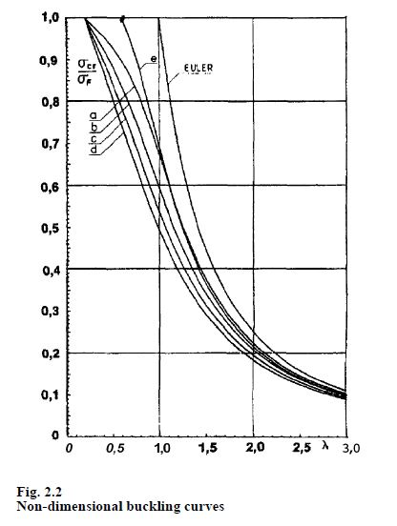

A section may be considered as “compact” for the purpose of this Note if the reduced slenderness with respect to local buckling of any part of the section is less than:

* 0.7 for plane parts of the cross section
* 0.5 for curved parts of the cross section.

Methods for evaluation of the reduced slenderness with respect to local buckling are given in the subsequent chapters. In cases where only the axial stress component is different from zero or

of any significance for local buckling, the cross section may be considered as compact if the following requirements are satisfied (see Fig. 2.4):

|  |  |
| --- | --- |
| Outstands | $$\frac{f}{t}≤0.4\sqrt{\frac{E}{σF}}$$ |
| Compressed flange in a box girder: | $$\frac{a}{t}≤1.35\sqrt{\frac{E}{σF}}$$ |
| Web plate with linear distribution of axial stresses: | $\frac{h}{d}≤\left(3.35-\sqrt{2\left(1+ψ\right)}\right)\frac{E}{σF} for-1≤$ $ψ≤1$ |
| Tubular cross sections: | $$\frac{D}{t}≤\frac{E}{9 σF}$$ |
| Shear buckling of the web plate at a position with only shear stresses may be disregarded if: | $$\frac{h}{d}≤2.0\sqrt{\frac{E}{σF}}$$ |

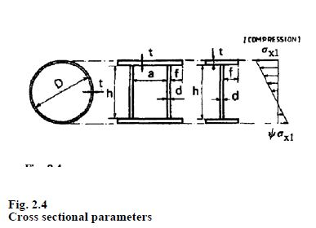

In cases where the geometric proportions are such that local instability may occur, the yield stress must be substituted by the characteristic local buckling stress. Local instability

need not be considered for “compact” sections as defined in 2.2.7.

The requirements given in 2.2.7 are not sufficient to secure development of full plastic hinges, which is a basic assumption in connection with plastic design methods.

A compression member which may be defined as both “stocky” and “compact” is not susceptible to buckling.

### Column Buckling.

For members which are not susceptible to local buckling, there are three different buckling modes to be considered:

* Flexural buckling.
* Torsional buckling.
* Flexural-torsional buckling.

The characteristic buckling stress, σacr, for members subjected to pure compression is the buckling stress corresponding to the critical buckling mode.

For members which may fail by flexural buckling, see 2.1.4, the buckling stress is obtained from Fig. 2.2 with λ defined by:

$$λ=\sqrt{\frac{σF}{σE}}=\frac{λK}{π}\sqrt{\frac{σF}{E}}$$

$$σE=\frac{π^{2}}{{λ_{k}}^{2}}=Euler Stress$$

$$λk=\frac{le}{i}$$

$$le=kl=effective length$$

$$i=\sqrt{\frac{I}{A}}=Radius of Gyration$$

Recommended values for K are given in Table 2-2 for a number of cases. For compression members in frames, see 2.6.

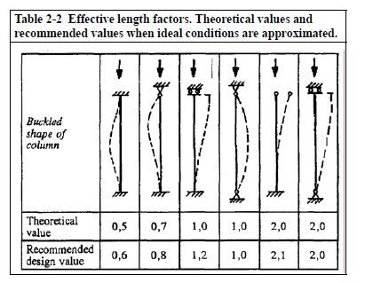

For members which may fail by torsional buckling, ser, the buckling stress is obtained from Fig. 2.2 curve “e”with λ defined by .

$$λ=\sqrt{\frac{σF}{σET}}$$

$σET=\frac{GI_{T}}{I_{P}}+\frac{π^{2}EC_{W}}{I_{P}{l_{e}}^{2}}$ =elastic torsional buckling stress

le = K = effective length with respect to warping

Ip = polar moment of inertia about the shear centre

IT = St. Venant torsional constant

CW= warping constant.

The parameters ITand CW are given in Table 2.3 for commonly used cross sections.

|  |  |
| --- | --- |
| **Cross sectional properties** | |
| Double Symmetrical Sections | |
|  | $$IT=\frac{1}{3} \left(2bt^{3}+hd^{3}\right)$$ |
| $$CW=\frac{h^{2}b^{3}t}{24}$$ |
|  | $$IT=\frac{2a^{2}h^{2}}{\frac{a}{t}+\frac{h}{d}}+\frac{2t^{3}\left(b-a\right)}{3}$$ |
| $$CW=\frac{\left({h^{2}I_{2}-a^{2}I_{2}}^{2}\right)}{2\left(h^{2}I_{1}+a^{2}I_{2}\right)}$$ Where $$I_{1}=\frac{1}{12} t b^{3}$$ $$I_{2}=\frac{1}{12} d h^{3}$$ |
| Point Symmetrical Sections | |
|  | $$It=2πr^{3}t$$ |
| $$CW=0$$ |
| $$IT=\frac{1}{3}\left(2bt^{3}+hd^{3}\right)$$ |
| $$Cw=\frac{h^{2}b^{3}t \left(bt+2hd\right)}{12 \left(2bt+hd\right)}$$ |
| Singly-Symmetrical Sections | |
|  | $$IT=\frac{1}{3}\left(2bt^{3}+hd^{3}\right)$$ |
| $$Cw=\frac{b^{3}t^{3}+4h^{3}d^{3}}{144}$$ |
| $$IT=\frac{1}{3}\left(bt^{3}+2hd^{3}\right)$$ |
| $$Cw=\frac{b^{2}h^{3}d \left(2bt+3hd\right)}{12 \left(bt+6hd\right)}$$ |
| $$IT=\frac{2bt^{3}}{3}$$ |
| $$cw=\frac{b^{3}t^{3}}{18}$$ |

In lieu of more accurate analysis, σET may be taken as:

$$σET=\frac{π^{2}EI_{f}}{A_{e}{I_{e}}^{2}}$$

If = moment of inertia of flange, see 2.5

Ae = effective cross sectional area, see Fig. 2.5.

(This simplified approach yields for doubly-symmetrical Hand I-shape sections:

$$σET\sim σE$$

where σE is the Euler stress for lateral buckling about the weak axis. This result is also obtained from 2.3.3 under the assumption that $I_{T}=0$ and $I_{P}=A {\left(\frac{h}{2}\right)}^{2}$.

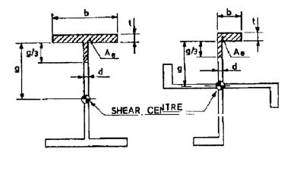

Cross-sectional properties to be used for simple evaluation of the torsional buckling strength.

$$I_{f}=\frac{1}{12} t b^{3}$$

$$I_{f}=\frac{1}{12} t b^{3} \left(\frac{1+4 \left(g \frac{d}{b}\right)t}{1+\left(g \frac{d}{b}\right)t}\right)$$

For members with one axis of symmetry (z-axis) and which may fail by flexural-torsional buckling, see 2.1.6, the buckling stress is obtained from Fig. 2.2 curve “b” with λ defined by:

$$λ=\sqrt{\frac{σF}{σET}}$$

$$σ_{EFT}=\frac{1}{2β}\left[\left(σ_{E}+σ_{ET}\right)-\sqrt{{\left(σ_{E}+σ_{ET}\right)}^{2}-4{βσ}_{E}σ_{ET}}\right]$$

$$β=1-\frac{{z_{o}}^{2} A}{I_{p}}$$

σE = Euler stress for buckling about the z-axis.

σEF = elastic torsional buckling stress.

σEFT = elastic flexural-torsional buckling stress.

A = cross sectional area.

Ip = polar moment of inertia about the shear centre.

zo = distance from centroid to shear centre along the zaxis.

The usage factor for member’s subjected compression is defined by

$$η=\frac{σ_{a}}{σ_{acr}}$$

The maximum allowable value of the usage factor, ηp, is defined in the rules (Type 3 structure).

### Lateral Torsional of Buckling system.

A beam which is subjected to bending about its strong axis (y-axis) and not restrained against buckling about the weak axis (z-axis) may fail by lateral-torsional buckling. Failure takes place when the largest compression stress reaches a critical value, σbcr, which is given by:

$$σ_{bcr}=σ_{v}$$

The lateral torsional buckling stress, σv, may be obtained from curve “e” in Fig. 2.2 by use of the reduced slenderness with respect to lateral-torsional buckling, λv.

The reduced slenderness with respect to lateral-torsional buckling is defined by:

$$λ_{v}=\frac{σ_{f}}{σ_{EV}}$$

$$σ_{EV}=\frac{π^{2}EI_{Z}C}{Z_{yc} {I_{e}}^{2}}$$

le = Kl = effective length with respect to warping

Zyc = section modulus with respect to compression flange

Iz = moment of inertia about the weak axis

c = parameter depending on geometric proportions, bending moment distribution and position of load with respect to the neutral axis.

For a beam with constant bending moment (bending moments applied at the ends):

$$c^{2}=\frac{C_{W}}{I_{z}}+\frac{I_{T}}{I_{Z}} \frac{{l_{e}}^{2}}{2π^{2}\left(1+ν\right)}$$

Cw = warping constant

IT = St. Venant torsional constant.

The parameters Cw and IT are shown in Table 2.3 for commonly used cross sections.

In lieu of more accurate analysis, σEV may be taken as:

$$σ_{EV}=\frac{π^{2}EI_{Zc}h}{Z_{yc} {I_{e}}^{2}}$$

Izc = moment of inertia of the compression flange (for doubly-symmetrical H- and I-shape sections Izc = Iz/2)

h = web height.

The simplified approach given in 2.4.4 yields for doubly-symmetrical H- and I-shape sections:

$$σEV\sim σE$$

where σE is the Euler stress for lateral buckling about the weak axis. This result is also obtained from 2.4.2 and 2.4.3 under the assumption that IT = 0 and Zyc = Ah / 2 (see also 2.3.4).

Lateral-torsional buckling need not be considered if:

$$l_{v}<0.6 or l_{e}<l_{eo}$$

$$l_{eo}=0.55\sqrt{ \frac{A_{c}h}{z_{yc}} \frac{E}{σ_{F}}}$$

le = laterally unsupported length

Ac = cross sectional area of compression flange

b = width of compression flange.

Lateral supports of the compression flange are to be designed for 2% of the total compression force that exists in the compression flange.

The usage factor for members subjected to pure bending is defined by:

$$η=\frac{σ_{b}}{σ_{bcr}}$$

The maximum allowable value of the usage factor, ηp, is defined in the rules (Type 2 structure).

### Buckling of beam-columns.

In lieu of more refined analysis, the usage factor for members subjected to compression and bending may be taken as:

$$η=\frac{σ_{a}}{σ_{acr}}+\frac{ασ_{b}}{\left(1-\frac{σ_{a}}{σ_{E}}\right)σ_{bcr}}$$

σa = Axial stress due to compression.

σb = Effective axial stress due to bending. Bending about weak (z-axis) or strong axis (yaxis) see options for σbcr.

For compression members which are braced against joint translation, σb is the maximum bending stress within the middle third of the length of the member,see Fig. 2.6.

σacr = Characteristic buckling stress for axial compression as defined in 2.3.

σE = Euler buckling stress always about weak axis (z-axis).

σbcr = Characteristic buckling stress for pure bending as defined in 2.4.1. If bending about weak axis (z-axis) then σbcr = σF.

α = Coefficient depending on type of structure and reduced slenderness according to the rules. Reduced slenderness as calculated critical for σacr.

For doubly symmetrical H- and I-shape and rectangular box sections which are subjected to simultaneous axial compression and bending about two axes, the usage factor may be taken as:

$$η=\frac{σ_{a}}{σ_{acr}}+\frac{ασ_{by}}{\left(1-\frac{σ_{a}}{σ_{E}}\right)σ_{bcr}}+\frac{ασ_{bz}}{\left(1-\frac{σ_{a}}{σ_{E}}\right)σ_{f}}$$

σby = effective axial stress due to bending about strong axis (y-axis).

σbz = effective axial stress due to bending about weak axis(z-axis).

Otherwise notation as under 2.5.1.

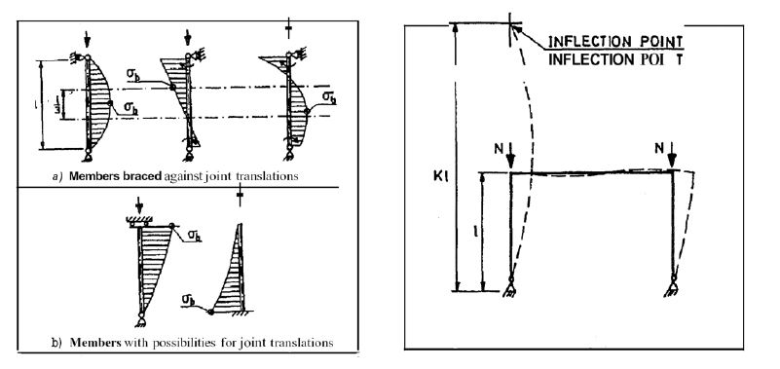

The maximum allowable value of the usage factor, ηp,is defined in the rules (Type 3 structure).

When the buckling analyses of a beam-column has been carried out by use of an effective bending stress, σb,which is less than the maximum bending stress, it is necessary to evaluate the usage factor with respect to yielding at the position of maximum bending stress.

### Buckling of frames.

Effective length factors for columns in a frame may be determined by computing the critical load for the complete frame or for a portion of the frame. The physical significance

of the effective length, le = Kl, is illustrated in Fig. 2.7. For the case shown in this figure, the value of K exceeds 2.0.

A procedure for determining K for braced and unbraced rectangular frames is based on the use of the alignment charts, shown in Fig. 2.8. At each end of the compressed member the following parameter is defined:

$$G= \frac{\sum{\frac{I_{C}}{I_{C}}}}{\sum{\frac{I_{b}}{I_{b}}}}$$

Σ indicates summation for all members rigidly connected to that joint and lying in the plane in which buckling of the column is being considered.

Ic, lc = moment of inertia and length of the compressed

members (columns)

Ib, lb = moment of inertia and length of the uncompressed

members (beams).

Having determined GA and GB for end A and end B of the member under consideration, K is obtained by constructing a straight line between the appropriate points on the scales for GA and GB.

The alignment charts given in Fig. 2.8 are based on the following assumptions:

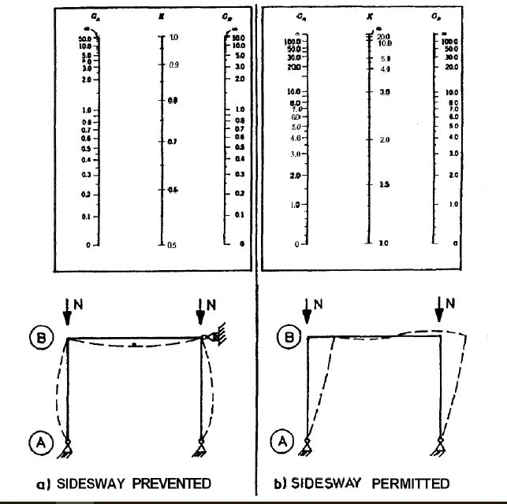

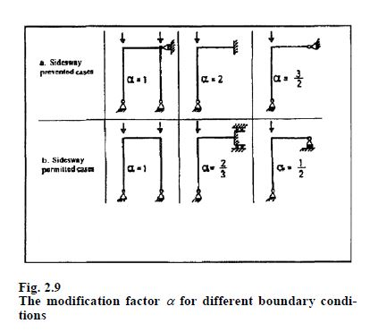

* behaviour is elastic
* all members have constant cross section
* all joints are rigid
* for the sidesway prevented case, rotations at the far ends of restraining beams are equal in magnitude but opposite in sense to the joint rotations at the columns ends (singlecurvature bending), see Fig. 2.8a
* for the sidesway unprevented case, rotations at the far ends of the restraining members are equal in magnitude and in the same sense as the joint rotations at the column ends (reverse curvature bending), see Fig. 2.8b
* the column stiffness parameter $l\sqrt{\frac{p}{EI}}$ must be identical for all columns
* the restraining moments provided by the beams at an end of a column are distributed between the columns in the ratio of the I/l values of the columns
* all columns in the frame buckle simultaneously.

$$G= \frac{\sum{\frac{I_{C}}{I_{C}}}}{\sum{\frac{I_{b}}{I_{b}}}}$$

where α is a correction factor depending on the boundary conditions at the far end on the beam, see Fig. 2.9.

When the moment connections between columns and beams are not fully rigid, G must be determined as:

$$G= \frac{\sum{\frac{I_{C}}{I_{C}}}}{\sum{αβ\frac{I_{b}}{I_{b}}}}$$

where β is a correction factor depending on the relative joint rigidity:

$$β=\frac{1}{1+\frac{c_{b}}{c_{j}}}$$

Cb = beam stiffness parameter

Cj = joint stiffness parameter.

The beam stiffness parameter is given by:

|  |  |
| --- | --- |
| For the sidesway prevented case: | $$C_{b}=2α\frac{EI_{b}}{l_{b}}$$ |
| For the sidesway permitted case: | $$C_{b}=6α\frac{EI_{b}}{l_{b}}$$ |

For the T-joint in-plane bending case shown in Fig. 2.10, the joint stiffness parameter may be taken as:

$$c_{j}=0.43ER^{3}{\left( \frac{T}{R}-0.01\right)}^{\left(2.35-1.5 \frac{r}{R}\right)}$$

For the T-joint out-of-plane bending case shown in Fig. 2.10,the joint stiffness parameter may be taken as:

$$c_{j}=0.216ER^{3}{\left(1.59- \frac{r}{R}\right)}^{\left(2.45-1.6 \frac{r}{R}\right)}$$

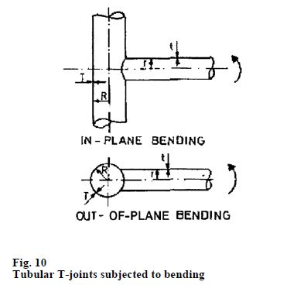

The expressions for Cj are only valid if:

$$0.33<\frac{r}{r}<0.8 and 10<\frac{R}{T}<30$$

A built-up member is here assumed to be composed of two or more sections (chords) separated from one another by intermittent transverse connecting elements (bracings), see Fig. 2.11. It is assumed that all connections are welded.

Overall buckling of a built-up member corresponds to flexural buckling of a homogenous member. The characteristic buckling stress may be obtained from Fig. 2.2 with λ defined by:

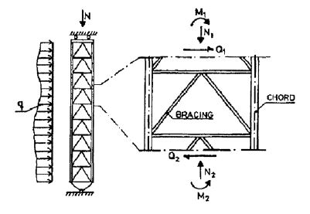

$$λ=\sqrt{\frac{σ_{F}}{σ_{E}}}$$

$$σ_{E}=\frac{π^{2}E}{(1+ω){λ_{k}}^{2}}=Euler stress$$

$$ω=2π^{2}\left(1+ν\right)\frac{I}{{l_{e}}^{2}A_{Q}}=Shear stifness modification factor$$

λk = le = column slenderness of the built-up member

regarded as homogenous

i = $\sqrt{\frac{I}{A}}$ = radius of gyration

le = Kl = effective length

A, AQ, I = cross sectional area, effective shear area, and

moment of inertia, see Tables 2.4 and 2.5

K = effective length factor to be

In addition to the overall buckling analysis, it is necessary to carry out buckling analysis for each single element of the built-up member.

If the characteristic buckling stress of a single chord element is less than the yield stress, the overall buckling analysis is to be based on a reduced yield stress equal to the characteristic

buckling stress of this chord element.

Bracing members, see Fig. 2.11, shall be designed to resist the effect of an overall shear force, Qd, given by:

$$Q_{d}=Q+Q_{o}$$

where Q is the maximum shear force due to design loading and Qo is defined by:

$$Q_{o}=π\frac{P}{P_{E}-P} \frac{M_{max}}{Kl} cos\frac{π}{kl}X$$

P = average axial force in each leg

PE = Euler buckling stress for the beam column

Mmax = maximum 1st order bending moment i.e. due to:

* lateral load
* eccentric axial load
* initial def. out of straightness

σcr = characteristic overall buckling stress of the built-up member determined in accordance with 2.7.2

x = distance from zero bending moment.

## Unstiffened spherical shells.

This chapter treats the buckling of unstiffened spherical shells and dished end closures.

The following symbols are used without a specific definition in the text where they appear.

E = Young's modulus.

N = axial load.

p = lateral pressure.

r = middle radius of the shell.

t = shell thickness.

σF = yield stress of the material as defined in the rules.

### Stresses.

Spherical shells are usually designed to resist lateral pressure. For a complete spherical shell subjected to uniform lateral pressure the state of stress is defined by the principal membrane stresses, σ1 and σ2, defined by:

For the spherical shell segment shown in Fig. 6.1, the meridional membrane stress is given by

$$σ_{φ}=\frac{pr}{2t}\frac{\sin\left(φ+α\right)\sin\left(φ-α\right)}{{\left(\sin{φ}\right)}^{2}}+\frac{N}{2πrt{\left(\sin{φ}\right)}^{2}}$$

The circumferential membrane stress is given by

$$σ_{θ}=\frac{pr}{t}-σ_{φ}$$

If the axial force, N, is due to end pressure alone, the stresses are given by

$$σ_{θ}=\frac{pr}{t}=σ_{φ}$$

These equations are only valid if the edges are reinforced. If the axial force is due to end pressure only, the required cross sectional area of the reinforcement is

$$A=\frac{\sin{2α}}{2\left(1-ν\right)}rt$$

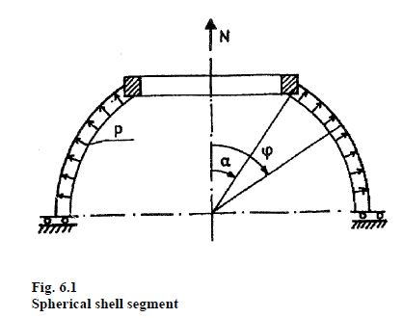

### Shell buckling, general.

Buckling of an unstiffened spherical shell occurs when the largest compressive principal membrane stress, σ1, reaches a critical value, σcr. The critical stress may be taken as.

$$σ_{cr}=\frac{σ_{F}}{\sqrt{1-ψ+ψ^{2}+λ^{4}}}$$

Where

$$ψ=\sqrt{\frac{σ_{2}}{σ_{1}}}=stress ratio\left(-1≤ψ≤1\right)$$

$$λ=\sqrt{\frac{σ_{F}}{σ_{E}}}=reduced slendreness$$

σ1 = largest compressive principal membrane stress

σ2 = principal membrane stress normal to σ1 (compressiveor tensile)

σE = elastic buckling stress.

The usage factor for shell buckling is defined by

$$η=\frac{σ_{1}}{σ_{cr}}$$

The maximum allowable value of the usage factor, ηp, is defined in the rules (Type 5 structure).

The elastic buckling stress σE may be taken as:

$$σ_{E}=0.606ρE\frac{t}{r}$$

In lieu of more detailed information ρ may be taken as:

$$ρ=\frac{0.5}{\sqrt{1+\frac{1}{100\left(3-2ψ\right)}\frac{r}{t}}}$$

For a complete sphere subjected to uniform external pressure the stress ratio is ψ = 1, and the expressions given above for σcr and ρ may be written as:

$$σ_{cr}=\frac{σ_{F}}{\sqrt{1+λ^{4}}}$$

$$ρ=\frac{0.5}{\sqrt{1+\frac{\frac{r}{t}}{100}}}$$

### Buckling of dished ends convex to pressure.

Hemispherical ends are to be designed as a complete sphere under uniform pressure.

Tori spherical ends are to be designed as a complete sphere with radius equal to the crown radius. However, the thickness should not be less than 1.2 times the thickness required for a structure of the same shape subjected to internal pressure.

Ellipsoidal ends are to be designed as a complete sphere with radius equal to $\frac{r2}{H}$, where H is the short axis and r is the long axis of the ellipsoid. However, the thickness should not be less than 1.2 times the thickness required for a structure of the same shape subjected to internal pressure.